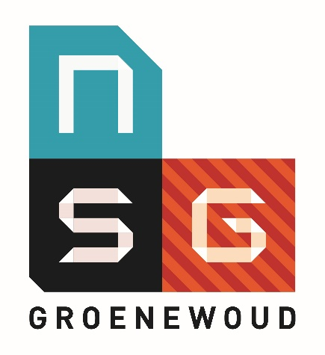
Antwoordformulier Vragen Open Dag Vakfilmpjes 2021
Naam: _______________________________________________________
Straat + huisnummer____________________________________________
Postcode/plaats: ____________________________________________________
Basisschool: ___________________________________________________
Email: ________________________________________________________

Geschiedenis
_______________________________________________________________________________

Muziek
_______________________________________________________________________________

Duits
_______________________________________________________________________________

Scheikunde
_______________________________________________________________________________

Filosofie
_______________________________________________________________________________

Wiskunde
_______________________________________________________________________________

Theater en Film
_______________________________________________________________________________

Engels
_______________________________________________________________________________

Aardrijkskunde
_______________________________________________________________________________

GLTC (Grieks en Latijn)
_______________________________________________________________________________

Economie
_______________________________________________________________________________

Frans
_______________________________________________________________________________

Beeldende vorming
_______________________________________________________________________________

Spaans
_______________________________________________________________________________

Nederlands
_______________________________________________________________________________

Biologie
_______________________________________________________________________________

Lichamelijke opvoeding
_______________________________________________________________________________

Stuur je antwoordformulier naar:
NSG Groenewoud
T.a.v. secretariaat
Antwoordnummer 1392
6500 VD NIJMEGEN
Het formulier mailen mag ook naar info@nsg-groenewoud.nl

